**Suzanne M. Leonard**

**March 26, 2023**

**Project #2**

**CMST 386**

**Client and Topic**

The purpose of the website will be to generate interest in the Northeast Florida running community.

Also, the aim will be to increase awareness of the running clubs and events in the local area. The

website will consist of pages related to topics such as fun runs, track runs, running apparel, races,

running coaches, running groups, and social and charity events. Local vendors and contractors will also

be able to advertise and sell running-related products through the website. Also, information relating to

clubs, coaches, and events will be on one website. I am a member of one of the running clubs and hope

to improve the flow of communication among runners and potential runners in the community.

**Development Process and Engagement**

I am designing the website for current and potential runners in the Northeast Florida community.

Individuals will be able to view information about the services the business offers. Also, runners will be

able to sign up for both independent sessions and packages on the websites. I will ask a mixture of

professionals and friends to test the parts of the website by taking steps such as clicking on boxes or

buttons. Observations will be conducted while the users navigate the website. The users will fill out

evaluation forms as I develop the website. That is how users will be involved in the

development process of the website. As I create the content of the website, I will research

sources such as online payment systems, types of imagery used for similar businesses, Adobe

Photoshop, and links to running-related websites.

**Testing**

Heuristic testing and evaluations will be conducted by professional developers, friends, clients,

and myself to ensure the website is complete and meets potential and current users’ requirements.

These heuristic evaluations will be conducted on a routine basis during the development of the website.

The users will test each part of the website to identify which sections work smoothly and efficiently.

Usability heuristics such as “visibility of system status,” “user control and freedom,”

“consistency and standards,” and “error prevention” will be rated by the experimental users

during the evaluations (Nielsen, “10 Usability Heuristics for User Interface Design,” 2020).

Chrome, Firefox, and Internet Explorer will be the browsers used throughout the testing

Processes.

**Description of Business and Website**

The website will draw together information related to running events, clubs, and coaches under one

umbrella. The coaches will be certified in their areas of expertise. The purpose of the

website is to improve potential clients’ awareness of the local running community and increase

awareness of running events and coaching among the community. Also, this business will be aimed at

enhancing and improving individuals’ running abilities and skills in the local Northeast Florida

community and in surrounding areas. The target audience of this business will consist of individuals in

the Northeast Florida community (Jacksonville, Orange Park, and St. Augustine) who seek to improve or

enhance their running and fitness skills. Also, the audience, consisting of various ethnic groups,

will dominantly encompass low-middle, middle-middle, upper-class individuals who are largely

knowledgeable of the internet and internet programs. However, the website will be accessible to

all individuals with internet access who may seek coaching services or access to group and independent

running activities. Many of these individuals use the internet daily to manage many of their activities

and will expect detailed information about services, experiences, and elaborate features such as

smooth-running shopping carts. Also, there is an increasing need for more coaches and

fitness trainers in this community as many individuals from different backgrounds have different

desires and fitness goals. I will tailor the website toward information relating to their interests

and experiences. Their will a place for testimonials from different clients describing their

experiences with running clubs and coaches to help potential clients understand the benefits of

Services. Moreover, there will be technologically efficient and effective e-commerce feature such as a

flexible payment options and plans. As a result of the demands of the target audience, the business’s

website will offer videos, photos, testimonials, and links to coaches and running workouts.

Also, the website will offer information about current trends and practices that will originate from

sources such as running clubs and running stores. The website’s content will be updated on a monthly

to quarterly basis.

**Growth**

I anticipate my personal business website will evolve over time. Testimonials related to runners’

experiences and feedback will be posted on the site. Gradually, my website will become more

connected into different networks. Additionally, more videos of running events and races

will be added to the website. Finally, the idea of online coaching will be added into the site when

an online coaching platform is eventually added. There will be routine monitoring of the website’s

content and functionalities. Biweekly to monthly monitoring of errors will be conducted through a

program such as Google Analytics which regularly monitor data relating to the site performance and

site usage. Price changes and the layout design will be monitored on a quarterly basis (“Developing and

Maintaining a Website,” 2020).

**Organization**

The content on this business website will be organized into a box layout. The users will click on

boxes or buttons to navigate to different pages which will lead to more information about each

topic (Babich, “Top Website Layouts That Never Grow Old,” 2019). There will be an opening

page which will consist of a top menu bar and nine major boxes. Users will be able to click on

these boxes. Once the users click on each box, they will be led to different pages consisting of

more information about the topic. These pages will also consist of click-on boxes that will lead

to information about subtopics such as running club schedules, race results, coaching methods and

results, social events, and links to running apparel and products. There will a home page, account sign-

up page, account login page, and information and plan purchase page. All pages will have “Go Back

To...” and“Go to Next Page” buttons to click on. Background images will be in the background on each

page. The screenshots below show the flow of the first nine webpages and how they are

connected (see the arrows in the flowchart and diagram).

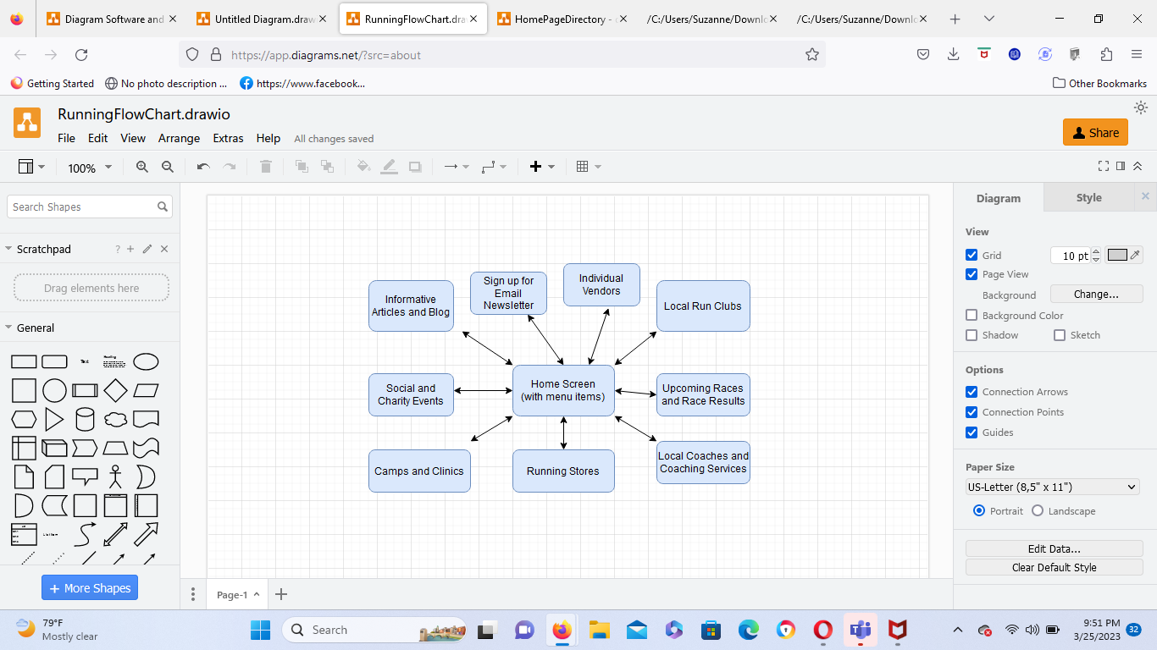

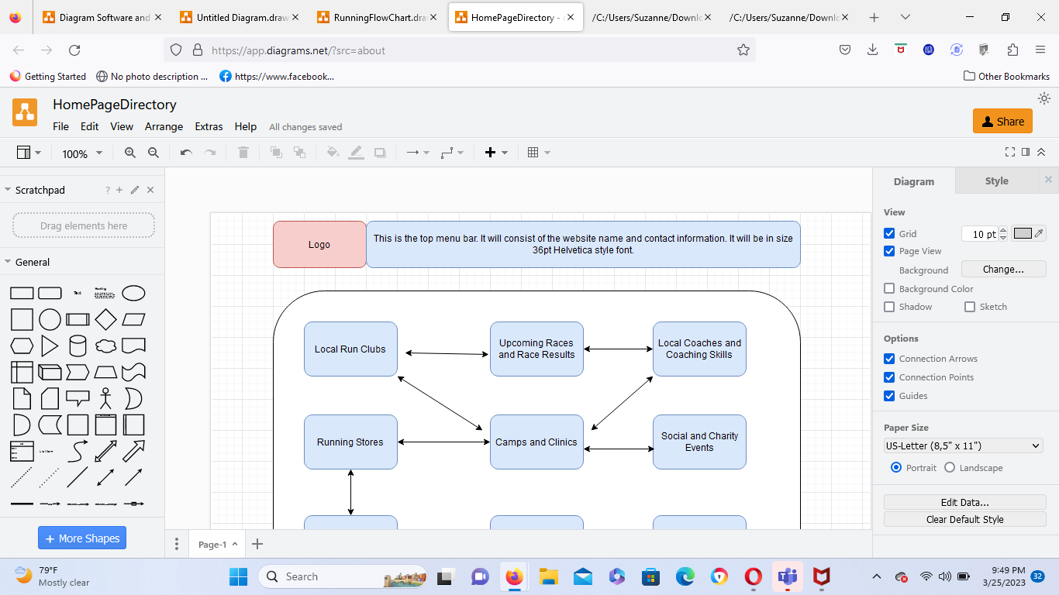

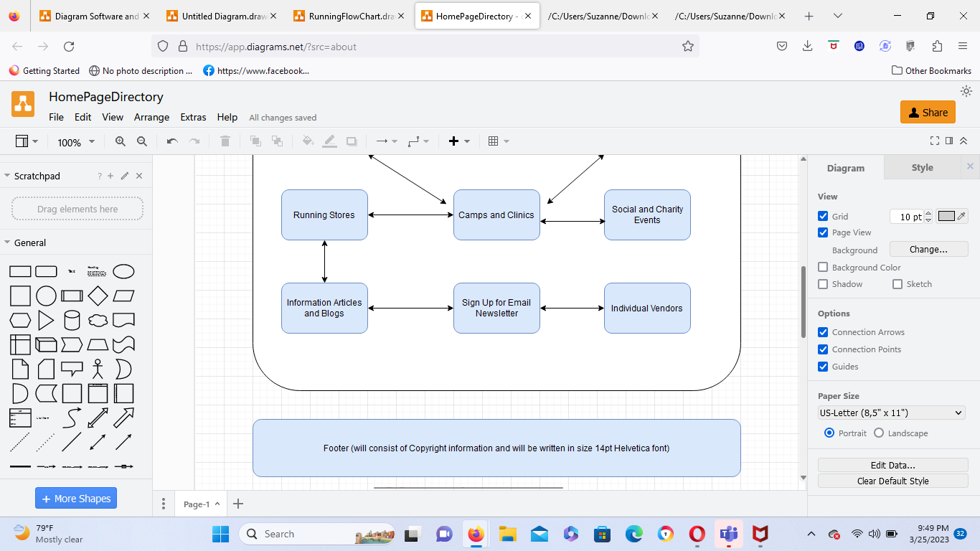

**Web Hosting**

There are several factors I will consider while I am selecting a web host for this website. First, I will research the quality and reliability of hardware services to ensure the price I pay is worth the investment (“Factors to Consider When Selecting a Web Host,” 2019). Also, I will consider the limitations and features the web host provides (“Factors…,” 2019). For example, I will determine whether my website will need a host that provides leeway for more elaborate features (rather than just simplistic blogs). Moreover, I will research the quality of the help and support system the web host servicer provides and will compare customer reviews of the web host. I will also base my decision on several factors including but not limited to user-friendliness, server collaboration and the quality of the control panels (“Factors…,” 2019). Special technologies allowing for several payment methods, flexible payment options, smart navigation, and discount code input boxes will be needed on this business website (“Factors..,” 2019). These technological capabilities and features are needed so my business can attract a wider variety of customers and increase sales. So, the website will make these e-commerce features accessible.

As a result of needing these features, the website will need to be supported by a mixture of front-end and back-end programming and scripting languages. HTML, which is supported by all browsers, will be used on the front-end because it is fast and simple (“15 Best Programming Language for Web Development in 2023,” 2022). CSS, which can be used collaboratively with HTML, will also be utilized on the front-end because the cascading sheets allow for simple customization of fonts and colors (“15 Best…,” 2022). Javascript, a programming language which can be used for both front-end and back-end development, tells which functions the buttons in the program will perform (“15 Best…,” 2022). So, Javascript will be utilized during the development of this website. Also, Python will also be used for the development of the back-end of the website because Python provides for excellent typing capabilities and paves the way for developers to create complex web pages that continuously need to be changed or updated (“15 Best..,” 2022). As far as the site domain name goes, I decided to choose “jaxruncommunity.com” because the “.com” domain is easy for use to remember and understand (“The Best Domain Name Generation,” 2023). This domain is also commonly used for businesses (“How to Choose…,” 2023).

**Marketing**

This business website will be marketed through the usage of content marketing, which will include sign-ups, business cards, downloadable brochures (“Entrepreneur: The 6 Online Marketing Strategies Every Entrepreneur Needs,” 2016). Also, social media marketing, email marketing, and search engine optimization (SEO) will be used to generate interest in the services and draw in clients. For example, social media will used to display newsletters and spur on more traffic to the website. While I am planning and building the website, some elements of search engine optimization will be developed. I will consider the content, content sources, market audience, competition from similar businesses, keywords, and the technical aspects of SEO (Miller, “The Four Pillars of an Effective SEO Strategy,” 2017). Understanding the language and interests of the target audience is very important during the website planning and building process. Also, understanding the extent to which content can be indexed is also crucial while developing SEO optimization (Miller, “The Four…,” 2017).

**Security**

This website will include an e-commerce component. For example, the website will have an easily navigable checkout and shopping cart feature. Also, there will be “discount calls to action.” (Mcomie, “6 Essential Components of an E-Commerce Website,” 2023). The content on the website will be password-protected. Individual clients’ account information and payment information will be password-protected. Also, some videos and tutorials will be password-protected. Users’ will be creating individual session purchasing accounts and email subscriber accounts so password-protection for user only pages is very necessary. To secure the website, the designer and developer will base the selection of a host on the host’s ability to provide security features such as content management systems and firewalls (Shirey, “9 Steps for Creating a Secure Website – Make Your Site Secure,” 2022).

**References**

Akash, S. (2020, Feb.). Top 10 programming languages for AR and VR developers in 2023. In

Analytics Insight. https://www.analyticsinsight.net/top-10-programming-languages-for-ar-and- vr-developers-in-2023/

Babich, N. (2019, Nov. 8). Top website layouts that never grow old. Adobe XD Ideas.

https://xd.adobe.com/ideas/principles/web-design/11-website-layouts-that-made-content- shine-in-2019/

Blogger, GMI. (2022, Nov. 29). 15 best programming languages for web development in 2023.

In GMI. https://www.globalmediainsight.com/blog/programming-languages-web- d development/

Diagram. (2023). Flowchart and diagram. In Diagram Software and flowchart.

https://digital.com/best-ecommerce-platforms/important-components-of-an-ecommerce- website/

Editorial Staff. (2023, Jan. 21). How to choose the best domain name (14 tips and tools). In WP

Beginner. https://www.wpbeginner.com/beginners-guide/tips-and-tools-to-pick-the-best- domain-for-your-blog/

Entrepreneur. (2016, July 14). Entrepreneur: The 6 online marketing strategies every

entrepreneur needs. In Entrepreneur. https://www.entrepreneur.com/growing-a-business/the- 6-online-marketing-strategies-every-entrepreneur-needs/278923

Johnson, Z. (2018, Feb. 9). Seven factors to consider when choosing a reliable web hosting

company. In YEC Council Post. https://www.forbes.com/sites/theyec/2018/02/09/seven- factors-to-consider-when-choosing-a-reliable-web-hosting-company/?sh=61a374004cab

Mcomie, A. (2023, Feb. 6). 6 essential components of an e-commerce website. In Digital.

https://digital.com/best-ecommerce-platforms/important-components-of-an-ecommerce- website/

Miller, M. (2017, Nov. 1). The four pillars of an effective SEO strategy. In Search Engine Land.

https://searchengineland.com/four-pillars-effective-seo-strategy-285584

Nameboy. (2023). The best domain name generation. In Nameboy. https://www.nameboy.com

Nielsen, J. (2020, Mar. 1). 10 usability heuristics for user interface design. In NN/g Nielsen

Norman Group. https://www.nngroup.com/articles/ten-usability-heuristics/

Penn State Extension. (2020, May 15). Developing and maintaining a website. In Penn State

Extension. https://extension.psu.edu/developing-and-maintaining-a-website

Shirey, T. (2023). 9 steps for creating a secure website – make your secure. In WebFx.

https://www.webfx.com/blog/web-design/creating-a-secure-website/

Velocity Consultancy. (2019, Jan. 4). Factors to consider when selecting a web host.

In CMS. https://www.velocityconsultancy.com/factors-to-consider-when-selecting-a-web-host/

YEC Council Host. (2018, Feb. 9). Seven factors to consider when choosing a reliable web

hosting company. In Entrepreneurs. https://www.forbes.com/sites/theyec/2018/02/09/seven- factors-to-consider-when-choosing-a-reliable-web-hosting-company/?sh=61a374004cab